IEEE 830
Software Requirements Specification
For
Home Network Security Health-Check Tool

Version 4
Prepared by Jakub Kasztelan
Lodz University of Technology, IFE
20.04.2026

Table of Contents
Appendix C: IEEE 830 1
Revision History 2
1. Introduction 3
1.1. Purpose 3
1.2. Intended Audience and Reading Suggestions 3
2. Overall Description 3
2.1. Product Perspective 3
2.2. Product Features 3
2.3. User Classes and Characteristics 3
2.4. Operating Environment 3
2.5. Design and Implementation Constraints 3
3. System Features 4
3.1. Network Auditing 4
3.2. Vulnerability Analysis and Scoring 4
3.3. Reporting and Export 4
4. External Interface Requirements 4
4.1. User Interfaces Overview 4
5. System Features/Modules 4
5.1. Network Audit Engine 4
6. Nonfunctional Requirements 5
7. System Architecture 5
7.1. Class Diagram 5
7.2. Data Flow (Sequence Diagram) 6

Revision History
Name | Date | Reason for Changes | Version
Jakub Kasztelan | 10.03.2026 | Initial version | V 1
Jakub Kasztelan | 23.03.2026 | Created Use Case Diagram, altered and specified functionality | V 2
Jakub Kasztelan | 14.04.2026 | Added Class Diagram | V 3
Jakub Kasztelan | 20.04.2026 | Refactored a project from Live Network Traffic Scanner to Network Health-Check tool. Changed all sections to suit the project and created Use Case, Class, Activity and Sequence diagrams to visualize the concept. | V 4

1. Introduction

1.1. Purpose
The purpose of the program is to enable non-technical people to audit their local network. The system shall identify connected devices, check for common security vulnerabilities (e.g. open ports or default password) and generate a score to help users decide if they need professional assistance to secure the network.

1.2. Intended Audience and Reading Suggestions
The system is intended for home users with little technical knowledge who want to ensure their local network is safe.

2. Overall Description

2.1. Product Perspective
The system is a new, stand-alone product. It runs on a personal computer and interacts with the local network without any additional hardware.

2.2. Product Features
- Device Discovery: Identification of all active devices on Wi-Fi.
- Vulnerability Audit: Scan for high-risk open ports (e.g. Telnet or FTP) and vulnerable services.
- Security Score: Translation of found weaknesses into a 0-100 score.
- Technical Report: Generate a PDF summary of findings to share with a professional.

2.3. User Classes and Characteristics
- Casual Home User: Individuals with basic technological knowledge who want a simple security status and a “contact a professional” indication.
- Network Technician: Professionals; use generated reports to understand the network vulnerabilities to fix.

2.3.1 Use Case Diagram
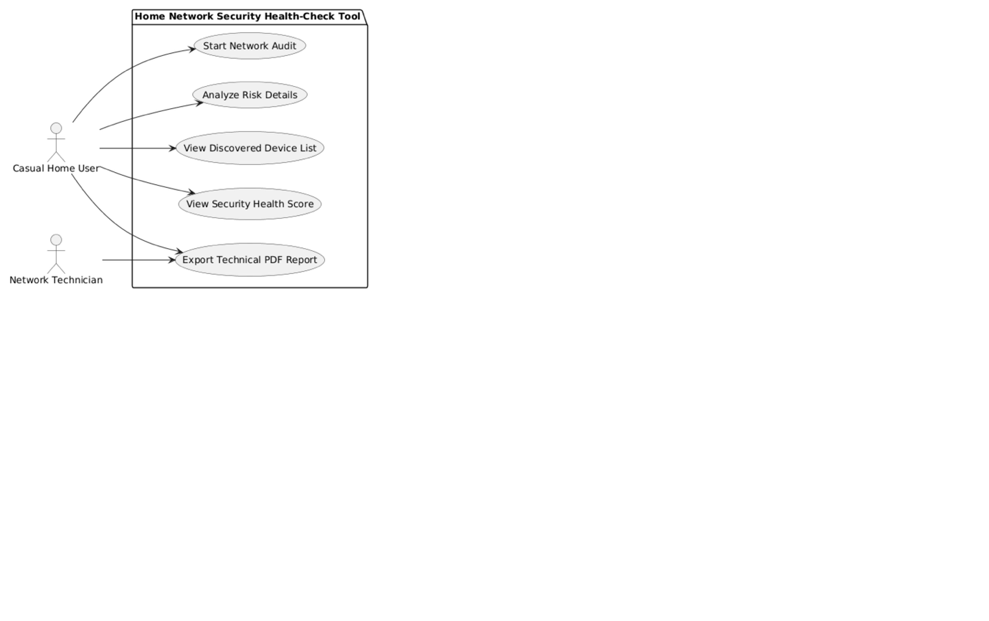

2.4. Operating Environment
The software operates on a standard PC (Windows 10/11, Linux or MacOS). It requires a network interface card (NIC) connected to a standard home router via Wi-Fi or Ethernet.

2.5. Design and Implementation Constraints
- Programming Language: Python.
- Permissions: The application may require administrative/sudo privileges to perform raw network scans.
- Privacy: The tool shall only scan the local subnet and cannot interfere with or "snoop" on external traffic (no ARP spoofing).

3. System Features
This section identifies the functionality of the system. Detailed functional requirements are provided in Section 5.

3.1. Network Auditing
The system shall discover all active devices on the local network and identify possible channels that are currently open and exposed, as well as common misconfigurations and vulnerabilities.

3.2. Vulnerability Analysis and Scoring
The system compares the data gathered during the audit to a database of known security risks and misconfigurations. It then calculates a "Security Health Score" between 0 and 100.

3.3. Reporting and Export
The system explains technical vulnerability findings in plain-English for non-technical users. It also allows to to export these findings into a structured PDF document for professional review.

4. External Interface Requirements

4.1. User Interfaces Overview
The system shall provide a web-based GUI, accessible from a standard browser. It shall be composed of:
- Main Status Dashboard: displays the current security score and a “Start Audit” button.
- Device List: Displays names and icons for all discovered devices.
- Risk Details: Explains found vulnerabilities in plain English.
- Export: Allows downloading the PDF report.

5. System Features/Modules

5.1. Network Audit Engine

5.1.1 Description and Priority
The core engine that discovers devices and checks for risks (High Priority).

5.1.2 Stimulus/Response Sequences
- Stimulus: User clicks "Start Audit".
- Response: System scans the subnet, creates the device list and calculates a health score.

5.1.3 Activity Diagram
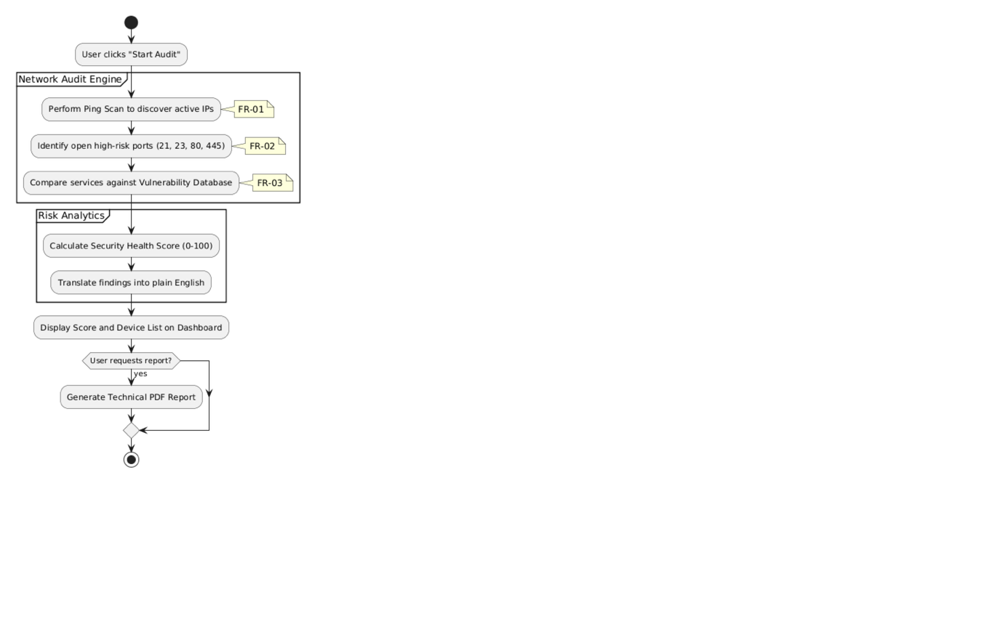

5.1.4 Functional Requirements
- FR-01: The system shall perform a ping scan to discover active IP addresses.
- FR-02: The system shall identify open high-risk ports 21, 23, 80, and 445 on found devices.
- FR-03: The system shall compare found services against a local database of known vulnerabilities.

6. Nonfunctional Requirements
- NFR-01 (Performance): A full small network audit (up to 20 devices) shall take no longer than 120 seconds.
- NFR-02 (Usability): All security risks shall be explained using non-technical terminology (e.g., "Unlocked Front Door" instead of "Open Port 23").
- NFR-03 (Safety): The scan shall not crash or slow down IoT devices on the network.

7. System Architecture

7.1. Class Diagram
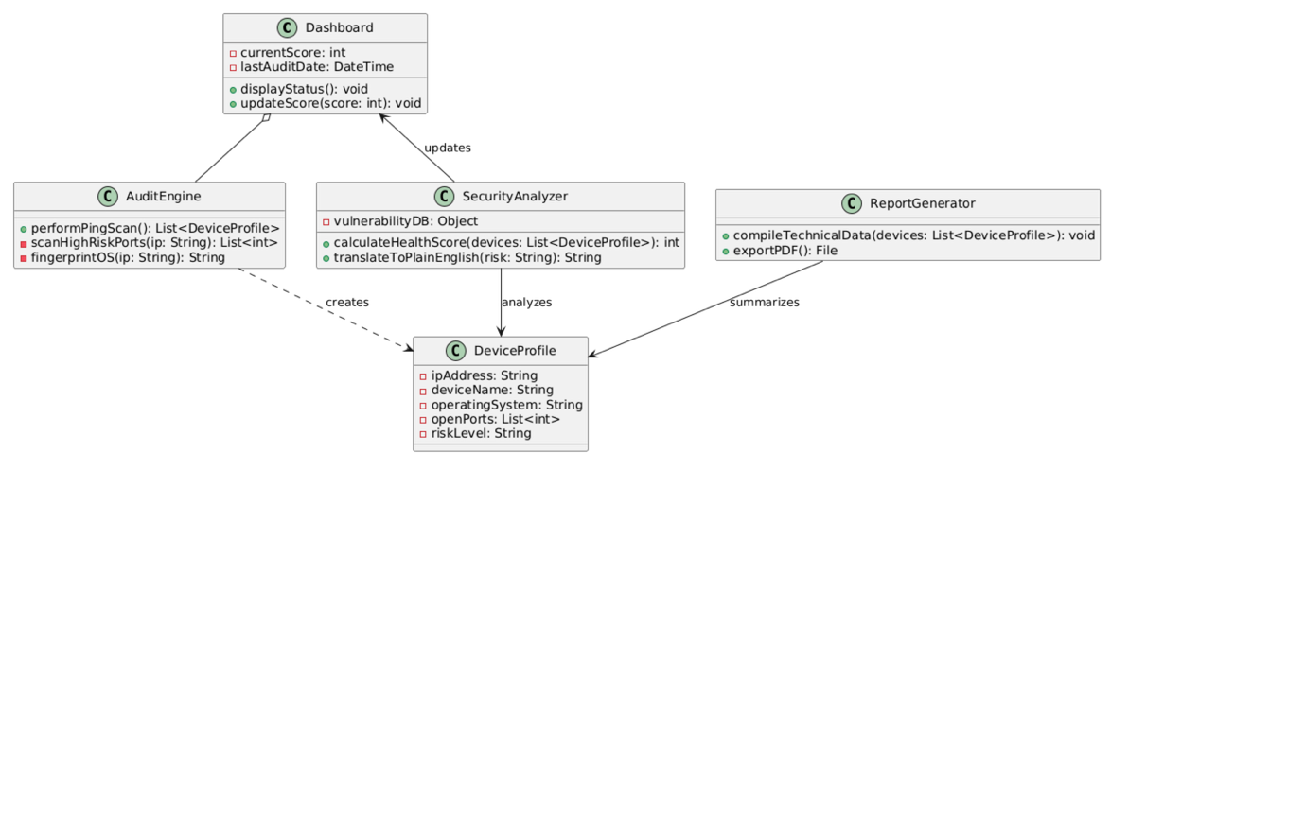

7.2. Data Flow (Sequence Diagram)
